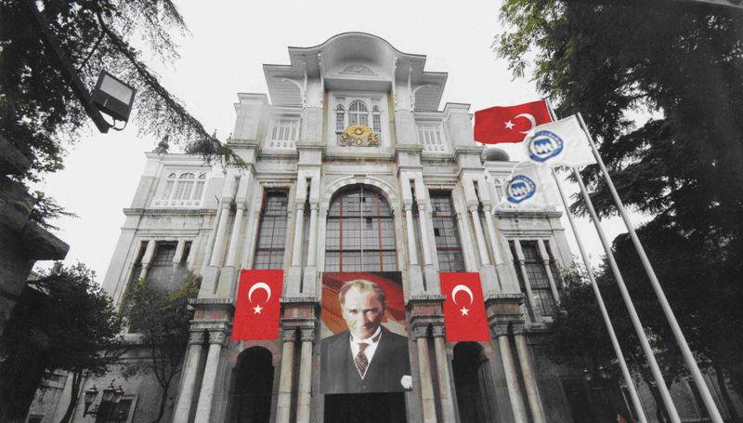
Marmara University
Vocational School of Justice

HISTORY OF CAMPUS:
The foundation of Haydarpasa campus, where our academy is also located, was laid on 11 February 1895. The date of the opening is the 6th November 1903. This date has a symbolic significance because of the fact that it coincide with the birth anniversary of Abdul Hamid II who was an Ottoman Sultan. The building has served the Medical School until 1933 and that year was transferred to the Ministry of Education who allocated it to the Haydarpasa High School founded in 1934. The building was used by Haydarpasa High School during a 50-year period between 1933-1983 and then was allocated to the University of Marmara in 1983.
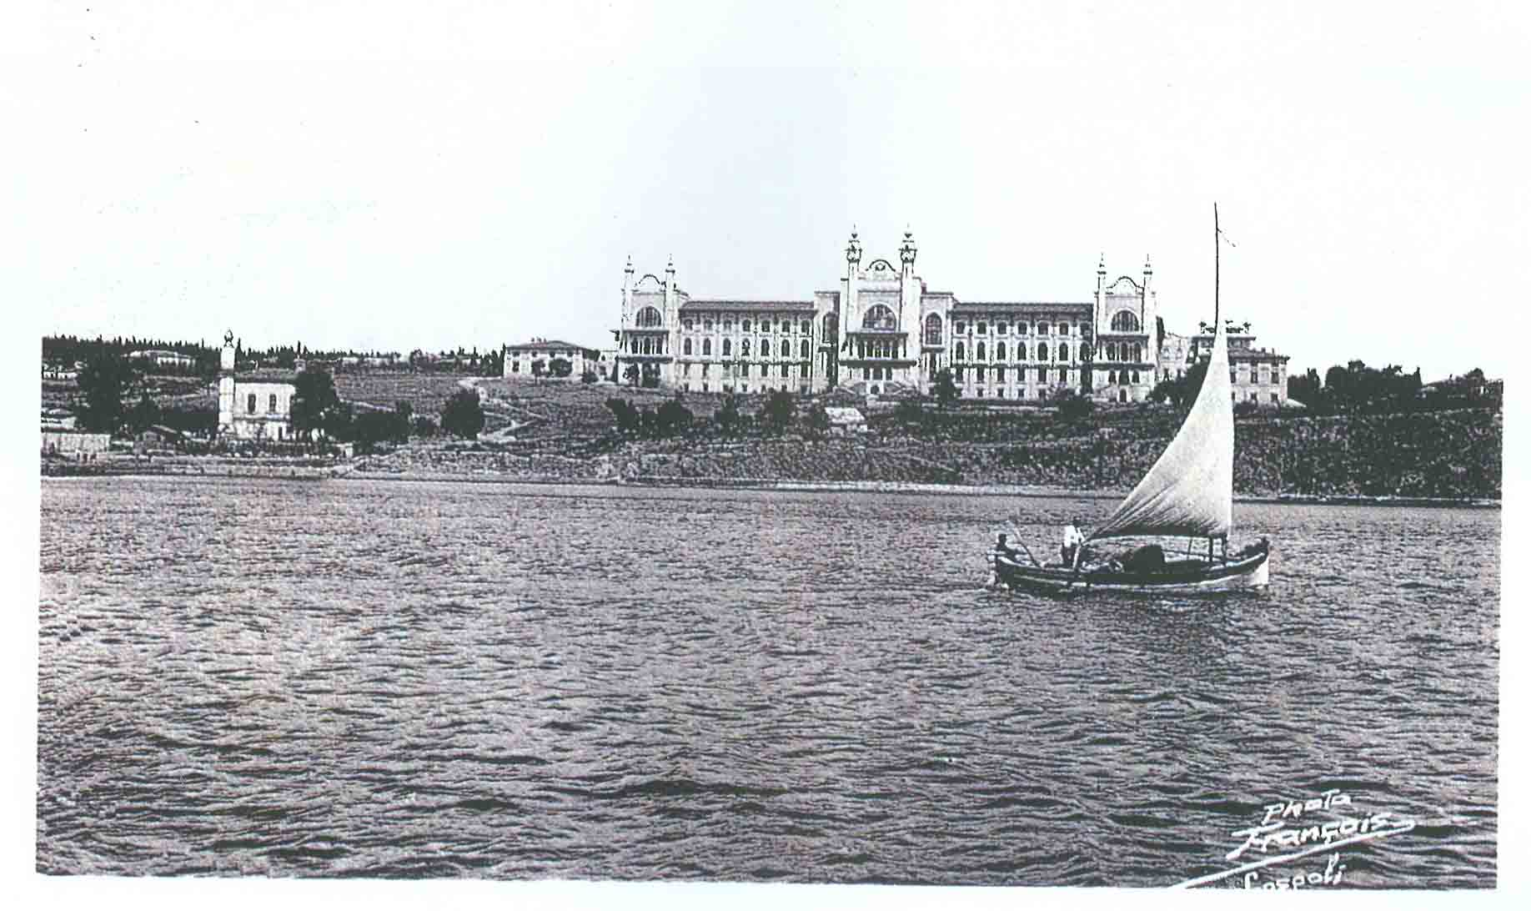
Within the Haydarpasa Campus, where our Vocational Law School is located, there are also the Faculties of Medicine, Law and Pharmacy, the Institute of Health Sciences, the School of Nursing and Health Services. Thus, students have the possibility to study in different areas of interest with a wide range of students.

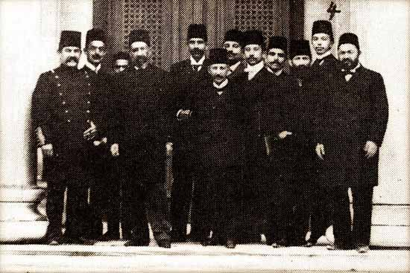
Forming the silhouette of the Anatolian side of Istanbul and the Selimiye Barracks in conjunction with the city's architectural fabric structures, the Haydarpasa Campus is one of the most magnificent buildings which were built within the Sultan Abdulhamid II. era with the goal of establishing a school better than similar schools in Europe. The architects of the building are Alexandre Vallaury and Raimondo D'Aronco.

The Importance of the Vocational Law School for the University
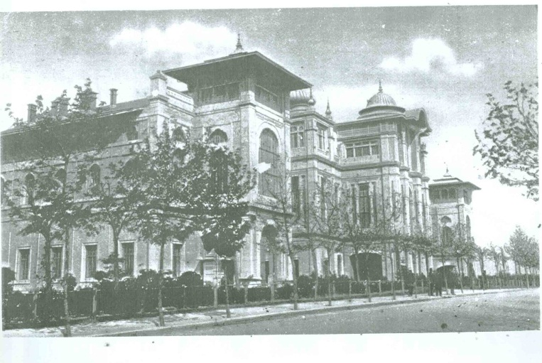
Founded with the decision of the General Board of Higher Education dated 23.09.2010 and within the scope of the Law Faculty, the Vocational Law School has a serious importance in fulfilling the need of qualified manpower in State and Private Institutions of Law which are in search of "Justice Personnel" and thus the School has accepted 46 students in its first year with an additional quota. For the academic year 2011-2012 a quota of 50 students has been determined and all of the students who have passed the exam have registered, in addition to two students who have joined us with the amnesty system. As a result, we actually have 98 students at our school. Vocational Law School had produced first graduates in 2011-2012 academic year.
The fact that Vocational Law School graduates are trained in accordance with the properties desired by State and Private Institutions has increased interest in School.
The Objective of the Vocational Law School Program
The purpose of the School is to train up qualified intermediary manpower that can provide the necessary help and assistance, particularly in judicial and penal institutions of the Ministry of Justice. The training lasts two years. Our students are trained in parallel with developments in the field of law, as equipped and experienced legal assistants who have great job opportunities in law firms located in big cities.
Students have at their disposal, the school’s library of Law, a reading room, a student cafeteria, a dining hall, sports facilities and the the Medico-Social Center within the building.
Major Courses Taught within the Program
Students are given theoretical and practical knowledge taking into account the qualifications required by justice services.
At the Vocational Law School, theoretical and practical courses such as; knowledge of public law and private law, legal information, legal procedure, criminal and criminal procedure, bankruptcy law, advocacy and notary legislation, financial legislation, legal language, medical jurisprudence, enforcement law, labour and social security law as well as typing, foreign languages, accounting, business management, archiving and filing techniques, juristic psychology are taught. The diversity and versatility of the courses gives our students the chance to have a wide career potential.
Required Qualifications
A student wishing to study at the Vocational Law School should have a keen interest in law and Turkish, in addition of being successful, meticulous, careful, and a person with feelings of responsibility.
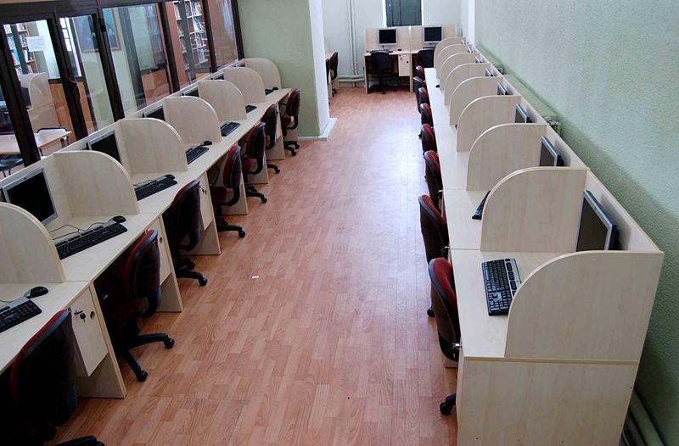
PHYSICAL CONDITION
In our school, there are 2 classrooms and a computer room with the capacity of 50 people.
The large Ord. Prof. Resat Kaynar ceremony hall is used for all ceremonies, conferences and scientific activities.

LIBRARY
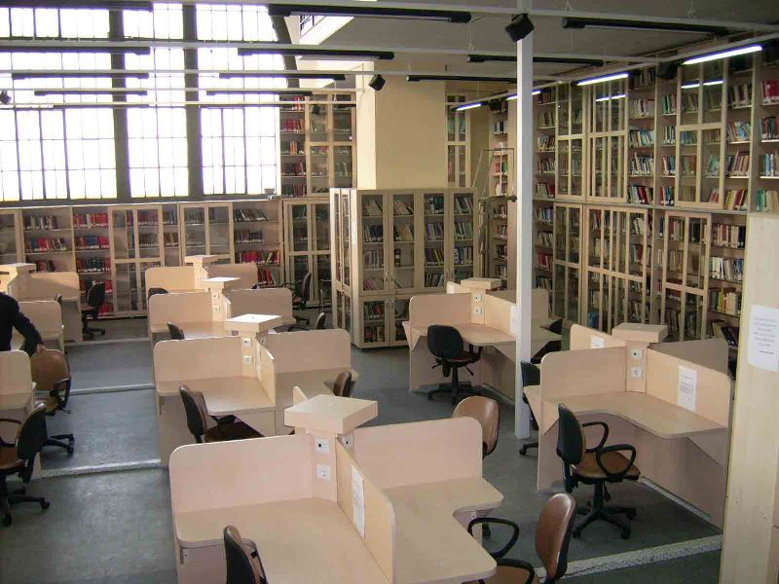
The Vocational Law School uses the library of the Faculty of Law which contains a wide range of books providing to teaching staff and students access to the information they need. A total of 33,669 books are available in domestic and foreign language at the library. There are many local and foreign periodicals. The catalog research system can also be used on internet in order to reach necessary information on current books within the library and international databases.
The library also welcomes researchers from outside the faculty and provides photocopying services. On the ground floor of the library there is a Reading Room with a capacity of 64 people for students, an Internet Center with 22 tables and on the first floor an academic research room with a capacity of 74 people.
Working Hours : From 8:30 a.m. to 5 p.m.
Service Opportunities: Photocopying, counseling services, answering questions about library use, the research questions that require the service, broadcast scan, the current announcement service, internet usage, internet access possibility of reaching library catalog and legislation on the Prime Ministry website and on the Kazancı Law Publications website.
Our students can also benefit from 7 days 24 hours open library in central Göztepe campus.
SOCIAL AND CULTURAL FACILITIES
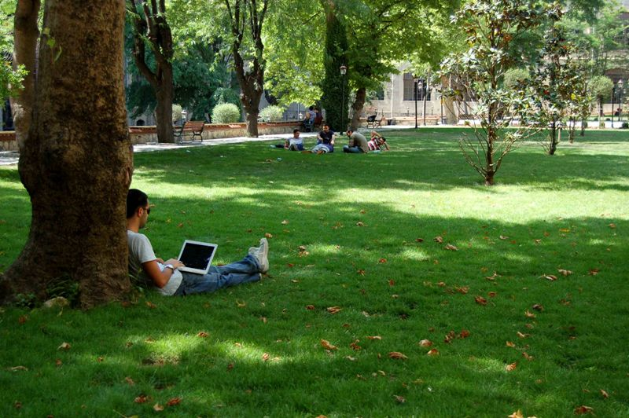
Our students benefit from the cafeteria and the refectory which are located on our campus. The campus has wired internet connection and a computer room containing 26 computers. The students can also benefit from the dormitory located at our Göztepe Campus (Özmen Aktar Dormitory), the dormitories within the structure of the Institution of Higher Education and other dormitories located at the European Side of Istanbul. Students can also enjoy sport facilities at our Göztepe, Haydarpasa and Anadoluhisarı Campuses. The Medico-Social Center located at the Haydarpasa Campus provides health care for the students and the personnel. Students can also enjoy other facilities located on other campuses.

The Title Earned After Graduation and Operating Areas for Graduates
The title of a finisher of the Vocational Law School’s program is "Professional Justice Personnel". Professional justice personnel can serve in government positions in addition to employment opportunities in various positions which are also available in private institutions and government agencies. Graduates may find job opportunities;
• At government bureaucracy,
•At the courts; transmitting citizens’ submitted applications to the courts and judges, performing the necessary procedures on issues such as implementation of courts’ decisions,
• Justice professionals are unified to the tasks with up to the courts and penal institutions directorate,
• At "Legal Advisor" sections of public or private banks, a variety of public or private institutions and organizations,
• At special economic enterprises,
• At Notaries,
• At Law Firms
• At companies' legal departments.

Contact Information:
Marmara University, Vocational Law School
Faculty of Law Building, Göztepe Campus
Kadıkoy / ISTANBUL 34722

Phone : (0 216) 777 2954
E-mail : adalet@marmara.edu.tr
Website : http://adalet.marmara.edu.tr

